**Getting Started with Grasshopper and Decodes**

**What You Should Already Have**

* ***Dynamo v0.7.0*** – Dynamo is an open source graphical programming interface. The current version is stand alone, and can also work with Autodesk’s Vasari and Revit. Dynamo is still experimental and in continuous development. Version 7.0 is the first one implementing the DesignScript programming language, which was used to build the interface with Decod.es. As Dynamo is in continuous development, new changes are made every day, and nodes developed for version 0.7.0 might not be compatible with future releases. To be able to run the decode node, you must run Dynamo v0.7.0. A fully-functional copy of Dynamo 0.7.0 may be downloaded from Autodesk at:

http://dynamobim.org/download/

**What You'll Need**

* Decodes Node (DecodesIronPython.dll, and DecodesIronPythonNode.dll) - Decodes is a *highly* experimental (read: unstable) plugin for Dynamo. Decodes is locally-sourced and free of BHa hormones. Updates to this plugin will no doubt be forthcoming throughout the semester, as bugs are squashed and essential new features added. The .dll files for this plugin will be provided.
* Decodes Library (a folder called “decodes”) – The decodes library contains the python code required to make the Decodes Plugin do its thing. Because this library is *highly* experimental, many updates will no doubt be forthcoming throughout the semester, so you should be prepared to frequently repeat the instructions below. The decodes library folder will be provided. Don’t mess around with the contents if you don’t know what you’re doing.

**What You Should Do**

1. If you don’t already own and have a copy of Dynamo 0.7.0 installed, go to the link above and install the 0.7.0 version.

Not sure how to tell which version of Dynamo you have?

1. Start Dynamo.
2. From the Dynamo Menu, select Help->About.
3. A tile should appear on the screen that looks a bit like the one below, which displays an identifier that tells us the version and release number in a format like this: “x.x.x.xxxx”. If you’re running the correct version of Dynamo, your identifier should be “0.7.0.4868”.
4. In windows explorer, browse to the Dynamo “Core” folder (see below for help).

Simply browse to the following location on your computer:

C:\Autodesk\Dynamo07\Core

1. Copy the one of the plugin files you were given (DecodesIronPython.dll) and the Decodes Library (the folder called “decodes”) into the Dynamo “Core” folder.
2. In windows explorer, browse to the Dynamo “Nodes” folder (see below for help).

Simply browse to the following location on your computer:

C:\Autodesk\Dynamo07\Core\nodes

1. Copy the last of the plugin files you were given (DecodesIronPythonNode.dll) into the Dynamo “Nodes” folder.
2. If you’re running Dynamo, close it.
3. Open Dynamo.
4. Test that everything worked.
   1. In Grasshopper, when you click on the search toolbar, and you type “Decodes”, can you see the results as shown below? Good.

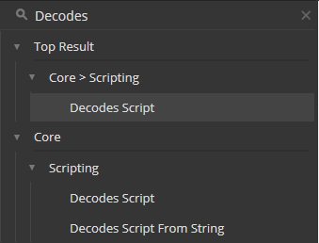

* 1. Click on the “Decodes Script” Node. The node will show up on the canvas.
  2. Double-click anywhere within the yellow area on the decodes component to open the Decodes IronPython Editor.
  3. Type the script shown below into the Decodes IronPython Editor and Click “OK”.

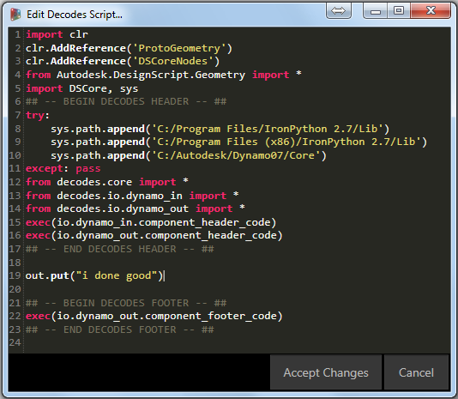

* 1. Make sure to type your code after line 17 (between ## -- END DECODEDES HEADER -- ##, and ## -- BEGIN DECODEDES FOOTER -- ##).
  2. Does the Decodes node get a “i done good” message when you hover over the white arrow of the node? Good.

1. Job Well Done!